One World Week Prayer 2019

Creator God
For our world of beauty and plenty, we praise you-
For the earth, the seas, the plants, the animals and all the wonders of the universe.
We stand before you in awe and wonder in all that you have created.
Thank you for your generosity - a world for all to share.
Create in us a desire to come together as One World, for Now is the Time to Act.

Redeemer God
Have mercy on us for our over-consumption of the world’s resources,
For our lack of responsibility in devastating the habitats of your creatures,
For our thoughtlessness in filling the world with our rubbish,
For the pursuit of economic growth which leaves our brothers and sisters in poverty.
Forgive us our selfishness that has led to this climate crisis, and bring us together as One World, for Now is the Time to Act.

Sustainer God
Be generous in your gifts of wisdom, understanding and courage to help us see:
the interconnectedness of climate, nature and our lifestyles,
our responsibility to secure a future for our children
and the urgency to act now
Inspire us to change personally, in our local communities, as nations and at a global level for we are One World, climate changes everything
and Now is the Time to Act
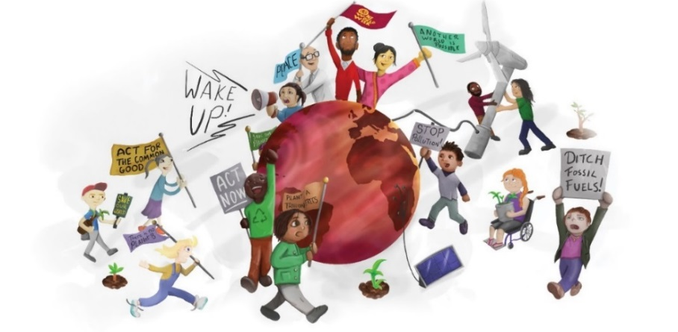
Amen

